**Assignment1 - Q1**

Addition in android studio

xml

<?xml version="1.0" encoding="utf-8"?>

<RelativeLayout xmlns:android="http://schemas.android.com/apk/res/android"

xmlns:app="http://schemas.android.com/apk/res-auto"

xmlns:tools="http://schemas.android.com/tools"

android:layout_width="match_parent"

android:layout_height="match_parent"

tools:context=".MainActivity">

<Button

android:id="@+id/button"

android:layout_width="wrap_content"

android:layout_height="wrap_content"

android:layout_alignParentEnd="true"

android:layout_alignParentBottom="true"

android:layout_marginEnd="296dp"

android:layout_marginBottom="377dp"

android:text="Add"

app:layout_constraintEnd_toEndOf="parent"

app:layout_constraintHorizontal_bias="0.117"

app:layout_constraintStart_toStartOf="parent"

tools:layout_editor_absoluteY="284dp" />

<EditText

android:id="@+id/val1"

android:layout_width="wrap_content"

android:layout_height="wrap_content"

android:layout_alignParentEnd="true"

android:layout_alignParentBottom="true"

android:layout_marginEnd="176dp"

android:layout_marginBottom="568dp"

android:ems="10"

android:inputType="textPersonName"

android:text=""

app:layout_constraintEnd_toEndOf="parent"

app:layout_constraintHorizontal_bias="0.164"

app:layout_constraintStart_toStartOf="parent"

tools:layout_editor_absoluteY="75dp" />

<EditText

android:id="@+id/val2"

android:layout_width="wrap_content"

android:layout_height="wrap_content"

android:layout_alignParentEnd="true"

android:layout_alignParentBottom="true"

android:layout_marginEnd="179dp"

android:layout_marginBottom="499dp"

android:ems="10"

android:inputType="textPersonName"

android:text=""

app:layout_constraintEnd_toEndOf="parent"

app:layout_constraintHorizontal_bias="0.164"

app:layout_constraintStart_toStartOf="parent"

tools:layout_editor_absoluteY="143dp" />

<TextView

android:id="@+id/result"

android:layout_width="wrap_content"

android:layout_height="wrap_content"

android:layout_alignParentEnd="true"

android:layout_alignParentBottom="true"

android:layout_marginEnd="383dp"

android:layout_marginBottom="446dp"

android:text=""

app:layout_constraintEnd_toEndOf="parent"

app:layout_constraintHorizontal_bias="0.093"

app:layout_constraintStart_toStartOf="parent"

tools:layout_editor_absoluteY="221dp" />

</RelativeLayout>

MainActivity.java

package com.example.a17_07_2024_androidlecture;

import androidx.appcompat.app.AppCompatActivity;

import android.os.Bundle;

import android.view.View;

import android.widget.Button;

import android.widget.EditText;

import android.widget.TextView;

public class MainActivity extends AppCompatActivity {

@Override

protected void onCreate(Bundle savedInstanceState) {

super.onCreate(savedInstanceState);

setContentView(R.layout.activity_main);

EditText ed1=(EditText) findViewById(R.id.val1);

EditText ed2=(EditText) findViewById(R.id.val2);

TextView te=(TextView) findViewById(R.id.result);

Button b=(Button) findViewById(R.id.button);

b.setOnClickListener(new View.OnClickListener() {

@Override

public void onClick(View view) {

int a = Integer.parseInt(ed1.getText().toString());

int b = Integer.parseInt(ed2.getText().toString());

int res;

res=a+b;

String s;

s=Integer.toString(res);

te.setText(s);

}

});

}

}

Output:

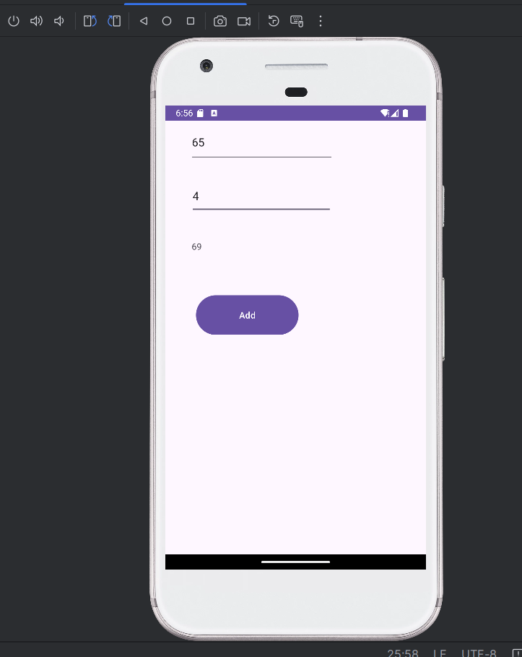

**Assignment Q2**

Basic Calculator in Android Studio

Xml

<?xml version="1.0" encoding="utf-8"?>

<RelativeLayout xmlns:android="http://schemas.android.com/apk/res/android"

xmlns:tools="http://schemas.android.com/tools"

android:layout_width="match_parent"

android:layout_height="match_parent"

tools:context=".MainActivity">

<EditText

android:id="@+id/val1"

android:layout_width="wrap_content"

android:layout_height="wrap_content"

android:hint="Value 1"

android:inputType="number"

android:layout_marginTop="50dp"

android:layout_centerHorizontal="true"/>

<EditText

android:id="@+id/val2"

android:layout_width="wrap_content"

android:layout_height="wrap_content"

android:hint="Value 2"

android:inputType="number"

android:layout_below="@id/val1"

android:layout_marginTop="20dp"

android:layout_centerHorizontal="true"/>

<TextView

android:id="@+id/res"

android:layout_width="wrap_content"

android:layout_height="wrap_content"

android:text="Result"

android:textSize="20sp"

android:layout_below="@id/val2"

android:layout_marginTop="20dp"

android:layout_centerHorizontal="true"/>

<Button

android:id="@+id/button_add"

android:layout_width="wrap_content"

android:layout_height="wrap_content"

android:text="Add"

android:layout_below="@id/res"

android:layout_marginTop="20dp"

android:layout_centerHorizontal="true"/>

<Button

android:id="@+id/button_sub"

android:layout_width="wrap_content"

android:layout_height="wrap_content"

android:text="Subtract"

android:layout_below="@id/button_add"

android:layout_marginTop="10dp"

android:layout_centerHorizontal="true"/>

<Button

android:id="@+id/button_mul"

android:layout_width="wrap_content"

android:layout_height="wrap_content"

android:text="Multiply"

android:layout_below="@id/button_sub"

android:layout_marginTop="10dp"

android:layout_centerHorizontal="true"/>

<Button

android:id="@+id/button_div"

android:layout_width="wrap_content"

android:layout_height="wrap_content"

android:text="Divide"

android:layout_below="@id/button_mul"

android:layout_marginTop="10dp"

android:layout_centerHorizontal="true"/>

</RelativeLayout>

MainActivity.java

package com.example.assignment2;

import androidx.appcompat.app.AppCompatActivity;

import android.os.Bundle;

import android.view.View;

import android.widget.Button;

import android.widget.EditText;

import android.widget.TextView;

public class MainActivity extends AppCompatActivity {

@Override

protected void onCreate(Bundle savedInstanceState) {

super.onCreate(savedInstanceState);

setContentView(R.layout.activity_main);

EditText ed1 = (EditText) findViewById(R.id.val1);

EditText ed2 = (EditText) findViewById(R.id.val2);

TextView te = (TextView) findViewById(R.id.res);

Button addButton = (Button) findViewById(R.id.button_add);

Button subButton = (Button) findViewById(R.id.button_sub);

Button mulButton = (Button) findViewById(R.id.button_mul);

Button divButton = (Button) findViewById(R.id.button_div);

addButton.setOnClickListener(new View.OnClickListener() {

@Override

public void onClick(View view) {

int a = Integer.parseInt(ed1.getText().toString());

int b = Integer.parseInt(ed2.getText().toString());

int res = a + b;

te.setText(Integer.toString(res));

}

});

subButton.setOnClickListener(new View.OnClickListener() {

@Override

public void onClick(View view) {

int a = Integer.parseInt(ed1.getText().toString());

int b = Integer.parseInt(ed2.getText().toString());

int res = a - b;

te.setText(Integer.toString(res));

}

});

mulButton.setOnClickListener(new View.OnClickListener() {

@Override

public void onClick(View view) {

int a = Integer.parseInt(ed1.getText().toString());

int b = Integer.parseInt(ed2.getText().toString());

int res = a * b;

te.setText(Integer.toString(res));

}

});

divButton.setOnClickListener(new View.OnClickListener() {

@Override

public void onClick(View view) {

int a = Integer.parseInt(ed1.getText().toString());

int b = Integer.parseInt(ed2.getText().toString());

if (b != 0) {

int res = a / b;

te.setText(Integer.toString(res));

} else {

te.setText("Cannot divide by zero");

}

}

});

}

}

Output:

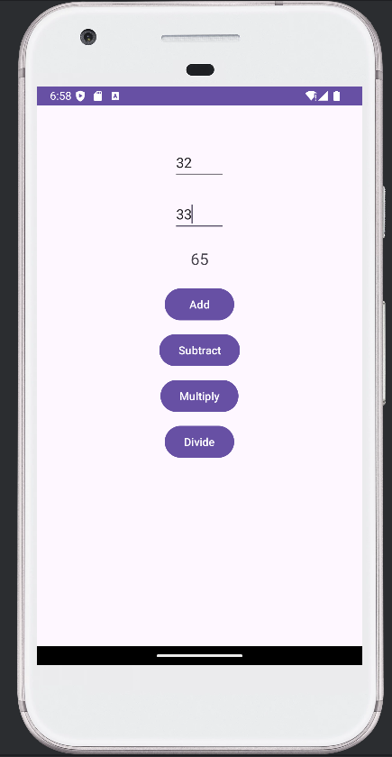 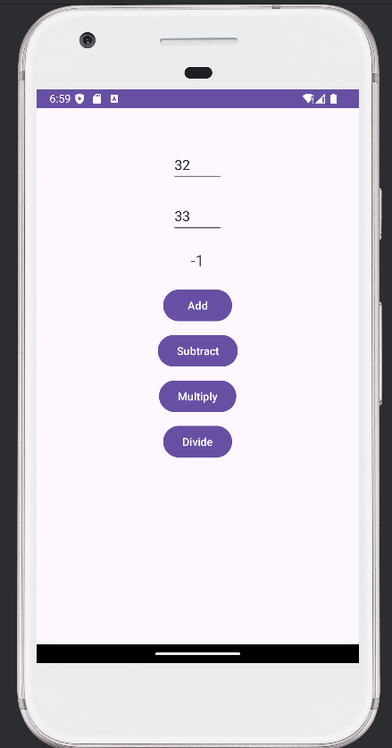

Addition Subtraction

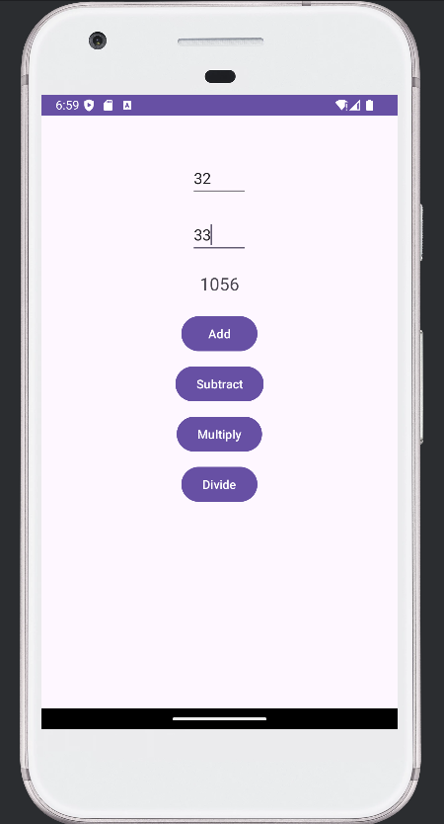 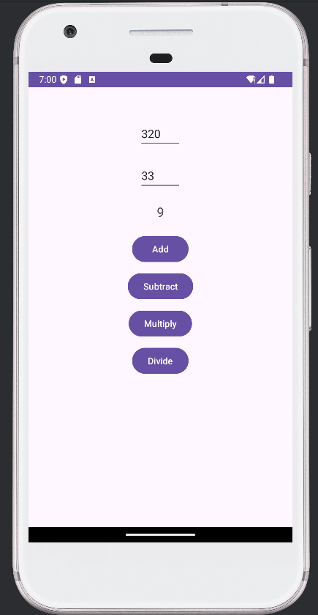

Multiplication Divide

**Assignment Q3**

Activity Lifecycle operations

Xml

<?xml version="1.0" encoding="utf-8"?>

<androidx.constraintlayout.widget.ConstraintLayout xmlns:android="http://schemas.android.com/apk/res/android"

xmlns:app="http://schemas.android.com/apk/res-auto"

xmlns:tools="http://schemas.android.com/tools"

android:id="@+id/main"

android:layout_width="match_parent"

android:layout_height="match_parent"

tools:context=".MainActivity">

<TextView

android:layout_width="wrap_content"

android:layout_height="wrap_content"

android:text="Hello World!"

app:layout_constraintBottom_toBottomOf="parent"

app:layout_constraintEnd_toEndOf="parent"

app:layout_constraintStart_toStartOf="parent"

app:layout_constraintTop_toTopOf="parent" />

</androidx.constraintlayout.widget.ConstraintLayout>

MainActicity.java

package com.example.assignment3;

import android.os.Bundle;

import androidx.activity.EdgeToEdge;

import androidx.appcompat.app.AppCompatActivity;

import androidx.core.graphics.Insets;

import androidx.core.view.ViewCompat;

import androidx.core.view.WindowInsetsCompat;

import android.util.Log;

public class MainActivity extends AppCompatActivity {

private static final String msg = "MainActivity";

@Override

protected void onCreate(Bundle savedInstanceState) {

super.onCreate(savedInstanceState);

EdgeToEdge.enable(this);

setContentView(R.layout.activity_main);

ViewCompat.setOnApplyWindowInsetsListener(findViewById(R.id.main), (v, insets) -> {

Insets systemBars = insets.getInsets(WindowInsetsCompat.Type.systemBars());

v.setPadding(systemBars.left, systemBars.top, systemBars.right, systemBars.bottom);

return insets;

});

Log.d(msg, "onCreate called");

}

@Override

protected void onStart() {

super.onStart();

Log.d(msg, "onStart called");

}

@Override

protected void onResume() {

super.onResume();

Log.d(msg, "onResume called");

}

@Override

protected void onPause() {

super.onPause();

Log.d(msg, "onPause called");

}

@Override

protected void onStop() {

super.onStop();

Log.d(msg, "onStop called");

}

@Override

protected void onDestroy() {

super.onDestroy();

Log.d(msg, "onDestroy called");

}

}

Output:

Logcat

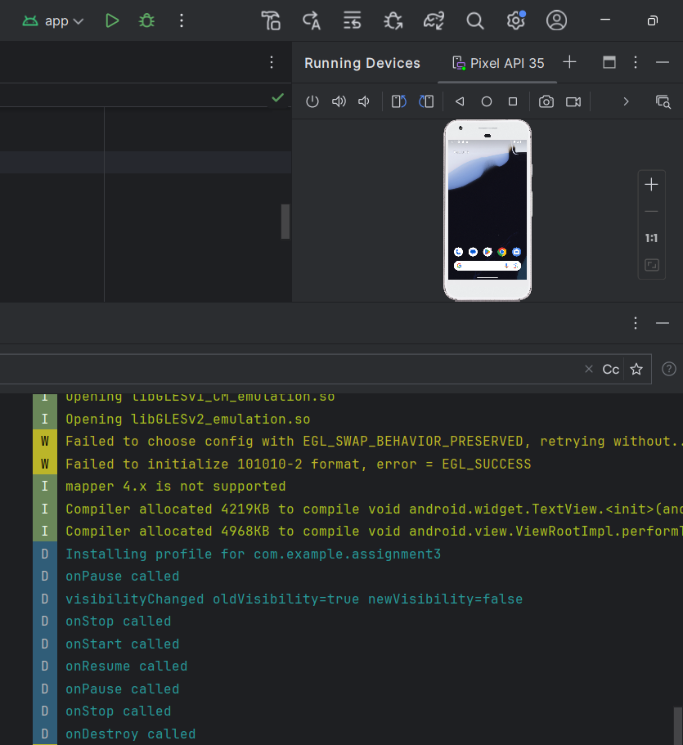

**Assignment Q4**

Xml

<?xml version="1.0" encoding="utf-8"?>

<RelativeLayout xmlns:android="http://schemas.android.com/apk/res/android"

xmlns:app="http://schemas.android.com/apk/res-auto"

xmlns:tools="http://schemas.android.com/tools"

android:id="@+id/main"

android:layout_width="match_parent"

android:layout_height="match_parent"

tools:context=".MainActivity">

<EditText

android:id="@+id/val1"

android:layout_width="wrap_content"

android:layout_height="wrap_content"

android:layout_alignParentEnd="true"

android:layout_alignParentBottom="true"

android:layout_marginEnd="184dp"

android:layout_marginBottom="542dp"

android:ems="10"

android:inputType="text"

android:text=""

tools:ignore="MissingConstraints"

tools:layout_editor_absoluteX="41dp"

tools:layout_editor_absoluteY="62dp" />

<EditText

android:id="@+id/val2"

android:layout_width="wrap_content"

android:layout_height="wrap_content"

android:layout_alignParentEnd="true"

android:layout_alignParentBottom="true"

android:layout_marginEnd="176dp"

android:layout_marginBottom="458dp"

android:ems="10"

android:inputType="text"

android:text=""

tools:ignore="MissingConstraints"

tools:layout_editor_absoluteX="42dp"

tools:layout_editor_absoluteY="141dp" />

<TextView

android:id="@+id/res"

android:layout_width="wrap_content"

android:layout_height="wrap_content"

android:layout_alignParentEnd="true"

android:layout_alignParentBottom="true"

android:layout_marginEnd="321dp"

android:layout_marginBottom="380dp"

android:text=""

tools:ignore="MissingConstraints"

tools:layout_editor_absoluteX="43dp"

tools:layout_editor_absoluteY="224dp" />

<Button

android:id="@+id/button"

android:layout_width="wrap_content"

android:layout_height="wrap_content"

android:layout_alignParentEnd="true"

android:layout_alignParentBottom="true"

android:layout_marginEnd="283dp"

android:layout_marginBottom="295dp"

android:text="Add"

tools:ignore="MissingConstraints"

tools:layout_editor_absoluteX="34dp"

tools:layout_editor_absoluteY="304dp" />

</RelativeLayout>

MainActivity.java

package com.example.myapplication;

import android.os.Bundle;

import android.view.View;

import android.widget.Button;

import android.widget.EditText;

import android.widget.TextView;

import android.widget.Toast;

import androidx.activity.EdgeToEdge;

import androidx.appcompat.app.AppCompatActivity;

import androidx.core.graphics.Insets;

import androidx.core.view.ViewCompat;

import androidx.core.view.WindowInsetsCompat;

public class MainActivity extends AppCompatActivity {

@Override

protected void onCreate(Bundle savedInstanceState) {

super.onCreate(savedInstanceState);

setContentView(R.layout.activity_main);

EditText ed1=(EditText) findViewById(R.id.val1);

EditText ed2=(EditText) findViewById(R.id.val2);

TextView te=(TextView) findViewById(R.id.res);

Button b=(Button) findViewById(R.id.button);

b.setOnClickListener(new View.OnClickListener() {

@Override

public void onClick(View view) {

int a=Integer.parseInt(ed1.getText().toString());

int b=Integer.parseInt(ed2.getText().toString());

int res;

res = a+b;

String s;

s=Integer.toString(res);

te.setText(s);

Toast.makeText(MainActivity.this,s+"is the sum",Toast.LENGTH_SHORT).show();

}

});

}

}

Output:

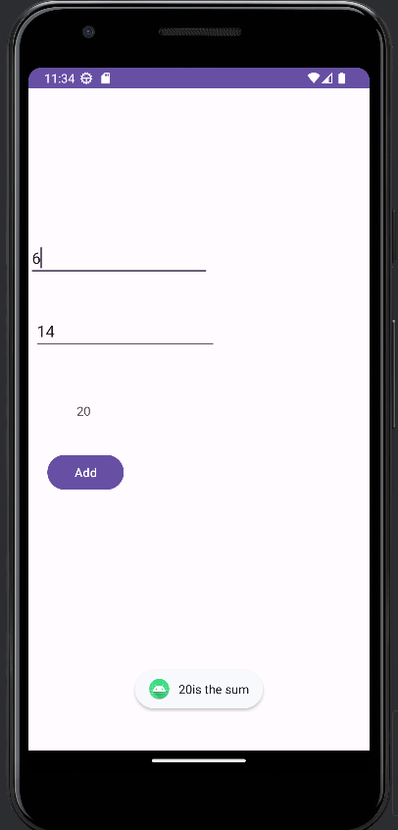

**Assignment Q5**

Xml

<?xml version="1.0" encoding="utf-8"?>

<RelativeLayout xmlns:android="http://schemas.android.com/apk/res/android"

xmlns:app="http://schemas.android.com/apk/res-auto"

xmlns:tools="http://schemas.android.com/tools"

android:id="@+id/main"

android:layout_width="match_parent"

android:layout_height="match_parent"

tools:context=".MainActivity">

<EditText

android:id="@+id/val1"

android:layout_width="wrap_content"

android:layout_height="wrap_content"

android:layout_alignParentEnd="true"

android:layout_alignParentBottom="true"

android:layout_marginEnd="184dp"

android:layout_marginBottom="542dp"

android:ems="10"

android:inputType="text"

android:text=""

tools:ignore="MissingConstraints"

tools:layout_editor_absoluteX="41dp"

tools:layout_editor_absoluteY="62dp" />

<TextView

android:id="@+id/res"

android:layout_width="wrap_content"

android:layout_height="wrap_content"

android:layout_alignParentEnd="true"

android:layout_alignParentBottom="true"

android:layout_marginEnd="321dp"

android:layout_marginBottom="380dp"

android:text=""

tools:ignore="MissingConstraints"

tools:layout_editor_absoluteX="43dp"

tools:layout_editor_absoluteY="224dp" />

<Button

android:id="@+id/button"

android:layout_width="wrap_content"

android:layout_height="wrap_content"

android:layout_alignParentEnd="true"

android:layout_alignParentBottom="true"

android:layout_marginEnd="283dp"

android:layout_marginBottom="295dp"

android:text="Check"

tools:ignore="MissingConstraints"

tools:layout_editor_absoluteX="34dp"

tools:layout_editor_absoluteY="304dp" />

</RelativeLayout>

MainActivity.java

package com.example.myapplication;

import android.os.Bundle;

import android.view.View;

import android.widget.Button;

import android.widget.EditText;

import android.widget.TextView;

import android.widget.Toast;

import androidx.appcompat.app.AppCompatActivity;

public class MainActivity extends AppCompatActivity {

private EditText ed1;

private TextView te;

@Override

protected void onCreate(Bundle savedInstanceState) {

super.onCreate(savedInstanceState);

setContentView(R.layout.activity_main);

ed1 = findViewById(R.id.val1);

te = findViewById(R.id.res);

Button b = findViewById(R.id.button);

b.setOnClickListener(new View.OnClickListener() {

@Override

public void onClick(View view) {

String input = ed1.getText().toString().trim(); // Trim to remove any leading/trailing spaces

if (!input.isEmpty()) {

try {

int number = Integer.parseInt(input);

String result = (number % 2 == 0) ? "Even" : "Odd";

te.setText(result);

Toast.makeText(MainActivity.this, number + " is " + result, Toast.LENGTH_SHORT).show();

} catch (NumberFormatException e) {

Toast.makeText(MainActivity.this, "Invalid number format", Toast.LENGTH_SHORT).show();

}

} else {

Toast.makeText(MainActivity.this, "Please enter a number", Toast.LENGTH_SHORT).show();

}

}

});

}

}

Output:

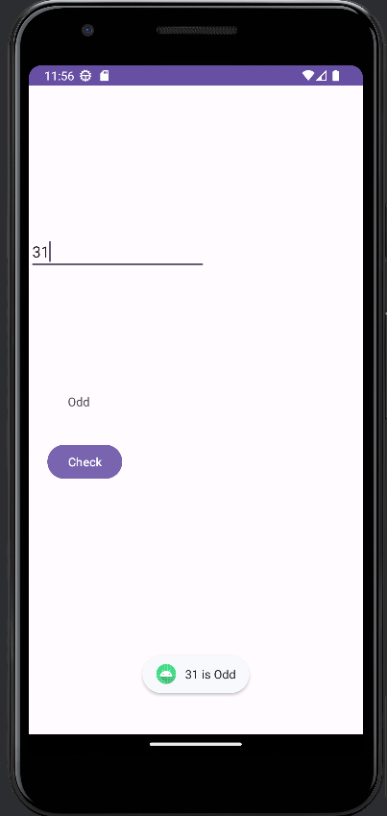 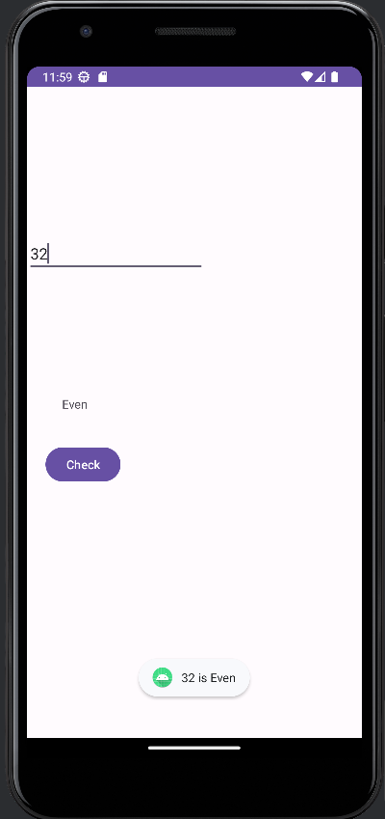

Odd Even

**Assignment Q6**

Xml

<?xml version="1.0" encoding="utf-8"?>

<RelativeLayout xmlns:android="http://schemas.android.com/apk/res/android"

xmlns:app="http://schemas.android.com/apk/res-auto"

xmlns:tools="http://schemas.android.com/tools"

android:id="@+id/main"

android:layout_width="match_parent"

android:layout_height="match_parent"

tools:context=".MainActivity">

<EditText

android:id="@+id/val1"

android:layout_width="wrap_content"

android:layout_height="wrap_content"

android:layout_alignParentEnd="true"

android:layout_alignParentBottom="true"

android:layout_marginEnd="171dp"

android:layout_marginBottom="583dp"

android:ems="10"

android:inputType="text"

android:text=""

tools:layout_editor_absoluteX="44dp"

tools:layout_editor_absoluteY="90dp" />

<Button

android:id="@+id/button"

android:layout_width="wrap_content"

android:layout_height="wrap_content"

android:layout_alignParentEnd="true"

android:layout_alignParentBottom="true"

android:layout_marginEnd="260dp"

android:layout_marginBottom="310dp"

android:text="Check"

tools:layout_editor_absoluteX="60dp"

tools:layout_editor_absoluteY="307dp" />

</RelativeLayout>

MainActivity.java

package com.example.a20_07_2024;

import android.os.Bundle;

import android.view.View;

import android.widget.Button;

import android.widget.EditText;

import android.widget.TextView;

import android.widget.Toast;

import androidx.appcompat.app.AppCompatActivity;

public class MainActivity extends AppCompatActivity {

private EditText e;

private Button b;

@Override

protected void onCreate(Bundle savedInstanceState) {

super.onCreate(savedInstanceState);

setContentView(R.layout.activity_main);

e = findViewById(R.id.val1);

b = findViewById(R.id.button);

b.setOnClickListener(new View.OnClickListener() {

@Override

public void onClick(View view) {

String numberStr = e.getText().toString().trim();

if (!numberStr.isEmpty()) {

int number = Integer.parseInt(numberStr);

if (isPrime(number)) {

showToast(number + " is a prime number");

} else {

showToast(number + " is not a prime number");

}

} else {

showToast("Please enter a number");

}

}

});

}

private boolean isPrime(int n) {

if (n <= 1) {

return false;

}

if (n <= 3) {

return true;

}

if (n % 2 == 0 || n % 3 == 0) {

return false;

}

for (int i = 5; i * i <= n; i += 6) {

if (n % i == 0 || n % (i + 2) == 0) {

return false;

}

}

return true;

}

private void showToast(String message) {

Toast.makeText(this, message, Toast.LENGTH_SHORT).show();

}

}

Output:

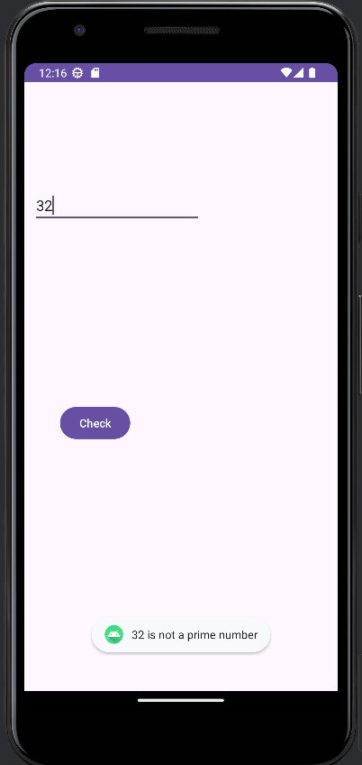 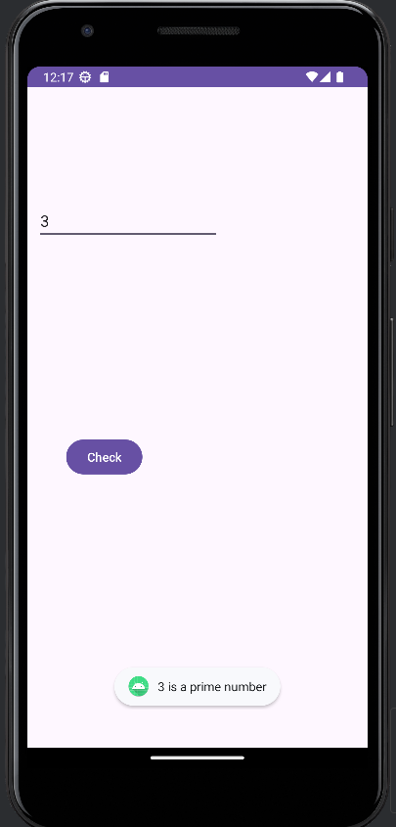

**Assignment Q7**

Xml

<?xml version="1.0" encoding="utf-8"?>

<RelativeLayout xmlns:android="http://schemas.android.com/apk/res/android"

xmlns:app="http://schemas.android.com/apk/res-auto"

xmlns:tools="http://schemas.android.com/tools"

android:id="@+id/main"

android:layout_width="match_parent"

android:layout_height="match_parent"

tools:context=".MainActivity">

<Button

android:id="@+id/color_b"

android:layout_width="wrap_content"

android:layout_height="wrap_content"

android:layout_alignParentEnd="true"

android:layout_alignParentBottom="true"

android:layout_marginEnd="248dp"

android:layout_marginBottom="410dp"

android:text="BG Color"

tools:ignore="MissingConstraints"

tools:layout_editor_absoluteX="77dp"

tools:layout_editor_absoluteY="316dp" />

<Button

android:id="@+id/image_b"

android:layout_width="wrap_content"

android:layout_height="wrap_content"

android:layout_alignParentEnd="true"

android:layout_alignParentBottom="true"

android:layout_marginEnd="105dp"

android:layout_marginBottom="414dp"

android:text="BG Image"

tools:ignore="MissingConstraints"

tools:layout_editor_absoluteX="231dp"

tools:layout_editor_absoluteY="316dp" />

</RelativeLayout>

MainActicity.java

package com.example.a22_07_2024;

import android.graphics.Color;

import android.os.Bundle;

import android.view.View;

import android.widget.Button;

import android.widget.EditText;

import android.widget.RelativeLayout;

import android.widget.TextView;

import android.widget.Toast;

import androidx.activity.EdgeToEdge;

import androidx.appcompat.app.AppCompatActivity;

import androidx.core.graphics.Insets;

import androidx.core.view.ViewCompat;

import androidx.core.view.WindowInsetsCompat;

public class MainActivity extends AppCompatActivity {

@Override

protected void onCreate(Bundle savedInstanceState) {

super.onCreate(savedInstanceState);

setContentView(R.layout.activity_main);

Button b1=(Button) findViewById(R.id.color_b);

Button b2=(Button) findViewById(R.id.image_b);

RelativeLayout r=(RelativeLayout) findViewById(R.id.main);

b1.setOnClickListener(new View.OnClickListener() {

@Override

public void onClick(View view) {

r.setBackgroundColor(Color.RED);

}

});

b2.setOnClickListener(new View.OnClickListener() {

@Override

public void onClick(View view) {

r.setBackgroundResource(R.drawable.ronaldo);

}

});

}

}

Output:

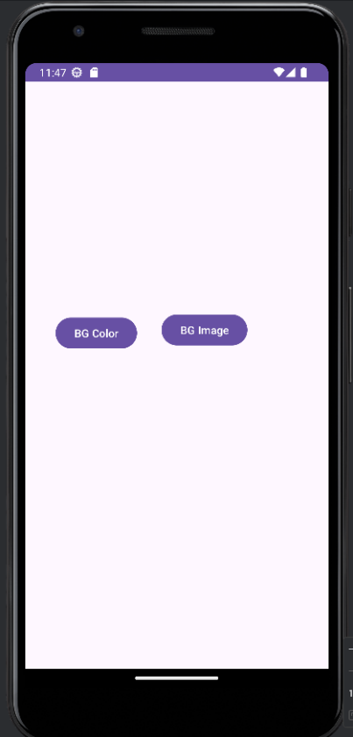 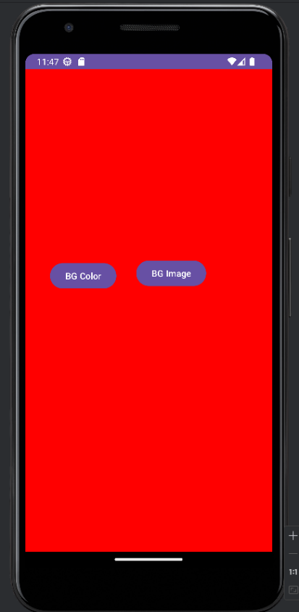 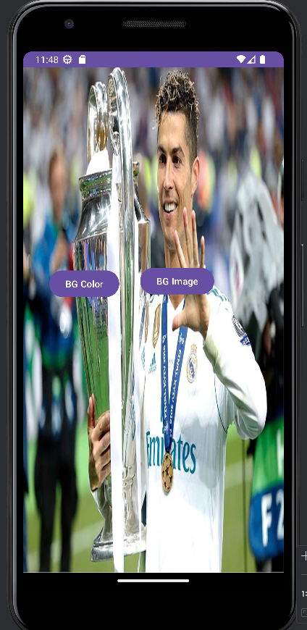

**Assignment Q8**

Xml

<?xml version="1.0" encoding="utf-8"?>

<LinearLayout xmlns:android="http://schemas.android.com/apk/res/android"

xmlns:app="http://schemas.android.com/apk/res-auto"

xmlns:tools="http://schemas.android.com/tools"

android:id="@+id/main"

android:layout_width="match_parent"

android:layout_height="match_parent"

android:orientation="vertical"

tools:context=".MainActivity"

tools:ignore="DisableBaselineAlignment">

<fragment

android:id="@+id/frag1"

android:layout_width="match_parent"

android:layout_height="wrap_content"

android:layout_weight="1"

tools:ignore="FragmentTagUsage"

android:name="com.example.a23_07_2024.first_fragment"

/>

<fragment

android:id="@+id/frag2"

android:layout_width="match_parent"

android:layout_height="wrap_content"

android:layout_weight="1"

tools:ignore="FragmentTagUsage"

android:name="com.example.a23_07_2024.second_fragment"/>

</LinearLayout>

MainActivity.java

package com.example.a23_07_2024;

import android.os.Bundle;

import androidx.activity.EdgeToEdge;

import androidx.appcompat.app.AppCompatActivity;

import androidx.core.graphics.Insets;

import androidx.core.view.ViewCompat;

import androidx.core.view.WindowInsetsCompat;

public class MainActivity extends AppCompatActivity {

@Override

protected void onCreate(Bundle savedInstanceState) {

super.onCreate(savedInstanceState);

setContentView(R.layout.activity_main);

}

}

fragment_first_fragment.xml

<?xml version="1.0" encoding="utf-8"?>

<LinearLayout xmlns:android="http://schemas.android.com/apk/res/android"

xmlns:tools="http://schemas.android.com/tools"

android:layout_width="match_parent"

android:layout_height="match_parent"

tools:context=".first_fragment"

android:orientation="vertical"

android:background="#673AB7">

<!-- TODO: Update blank fragment layout -->

<TextView

android:layout_width="match_parent"

android:layout_height="match_parent"

android:text="My first fragment"

android:id="@+id/fragmentxml1"/>

</LinearLayout>

fragment_second_fragment.xml

<?xml version="1.0" encoding="utf-8"?>

<FrameLayout xmlns:android="http://schemas.android.com/apk/res/android"

xmlns:tools="http://schemas.android.com/tools"

android:layout_width="match_parent"

android:layout_height="match_parent"

tools:context=".second_fragment"

android:orientation="vertical"

android:background="#FF5722"

>

<!-- TODO: Update blank fragment layout -->

<TextView

android:layout_width="match_parent"

android:layout_height="match_parent"

android:text="My second fragment"

android:id="@+id/fragmentxml2"/>

</FrameLayout>

first_fragment.java

package com.example.a23_07_2024;

import android.os.Bundle;

import androidx.fragment.app.Fragment;

import android.view.LayoutInflater;

import android.view.View;

import android.view.ViewGroup;

import android.widget.TextView;

public class first_fragment extends Fragment {

public first_fragment() {

// Required empty public constructor

}

@Override

public View onCreateView(LayoutInflater inflater, ViewGroup container,

Bundle savedInstanceState) {

// Inflate the layout for this fragment

View view = inflater.inflate(R.layout.fragment_first_fragment, container, false);

return view;

}

}

second_fragment.java

package com.example.a23_07_2024;

import android.os.Bundle;

import androidx.fragment.app.Fragment;

import android.view.LayoutInflater;

import android.view.View;

import android.view.ViewGroup;

public class second_fragment extends Fragment {

public second_fragment() {

// Required empty public constructor

}

@Override

public View onCreateView(LayoutInflater inflater, ViewGroup container,

Bundle savedInstanceState) {

// Inflate the layout for this fragment

View view = inflater.inflate(R.layout.fragment_second_fragment, container, false);

return view;

}

}

Output:

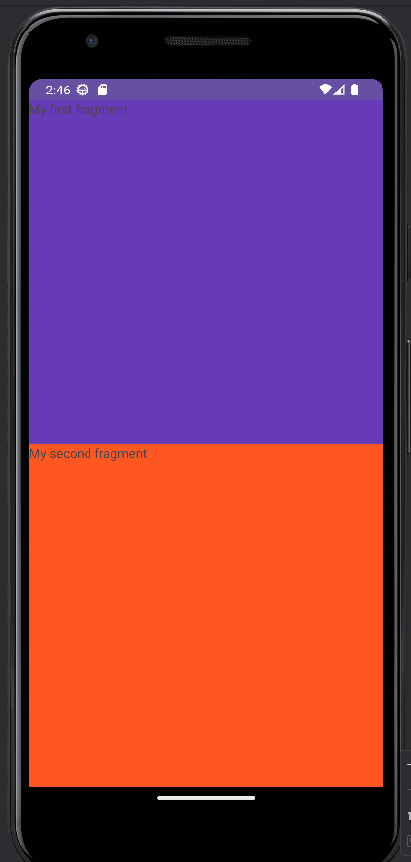

Assignment Q9

MainActivity.java

package com.example.assignment9;

import android.os.Bundle;

import android.view.View;

import android.widget.Button;

import androidx.activity.EdgeToEdge;

import androidx.appcompat.app.AppCompatActivity;

import androidx.core.graphics.Insets;

import androidx.core.view.ViewCompat;

import androidx.core.view.WindowInsetsCompat;

import androidx.fragment.app.Fragment;

import androidx.fragment.app.FragmentManager;

import androidx.fragment.app.FragmentTransaction;

public class MainActivity extends AppCompatActivity {

Button btnA,btnB,btnC;

@Override

protected void onCreate(Bundle savedInstanceState) {

super.onCreate(savedInstanceState);

setContentView(R.layout.activity_main);

btnA=findViewById(R.id.b1);

btnB=findViewById(R.id.b2);

btnC=findViewById(R.id.b3);

loadfrag(new BFragment(),0);

btnA.setOnClickListener(new View.OnClickListener() {

@Override

public void onClick(View view) {

loadfrag(new AFragment(),1);

}

});

btnB.setOnClickListener(new View.OnClickListener() {

@Override

public void onClick(View view) {

loadfrag(new BFragment(),1);

}

});

btnC.setOnClickListener(new View.OnClickListener() {

@Override

public void onClick(View view) {

loadfrag(new CFragment(),1);

}

});

}

public void loadfrag(Fragment frag, int flag){

FragmentManager fm=getSupportFragmentManager();

FragmentTransaction ft=fm.beginTransaction();

if (flag == 0)

ft.add(R.id.frm,frag);

else

ft.replace(R.id.frm,frag);

ft.commit();

}

}

Activity_main.xml

<?xml version="1.0" encoding="utf-8"?>

<LinearLayout xmlns:android="http://schemas.android.com/apk/res/android"

xmlns:app="http://schemas.android.com/apk/res-auto"

xmlns:tools="http://schemas.android.com/tools"

android:layout_width="match_parent"

android:layout_height="match_parent"

tools:context=".MainActivity"

android:orientation="vertical">

<LinearLayout

android:layout_width="match_parent"

android:layout_height="wrap_content">

<Button

android:layout_width="wrap_content"

android:layout_height="wrap_content"

android:id="@+id/b1"

android:layout_weight="1"

android:text="Frag1"/>

<Button

android:layout_width="wrap_content"

android:layout_height="wrap_content"

android:id="@+id/b2"

android:layout_weight="1"

android:text="Frag2"/>

<Button

android:layout_width="wrap_content"

android:layout_height="wrap_content"

android:id="@+id/b3"

android:layout_weight="1"

android:text="Frag3"/>

</LinearLayout>

<FrameLayout

android:layout_width="match_parent"

android:layout_height="match_parent"

android:id="@+id/frm"/>

</LinearLayout>

AFragment.java

package com.example.assignment9;

import android.os.Bundle;

import androidx.fragment.app.Fragment;

import android.view.LayoutInflater;

import android.view.View;

import android.view.ViewGroup;

public class AFragment extends Fragment {

public AFragment() {

// Required empty public constructor

}

@Override

public View onCreateView(LayoutInflater inflater, ViewGroup container,

Bundle savedInstanceState) {

// Inflate the layout for this fragment

return inflater.inflate(R.layout.fragment_a, container, false);

}

}

Fragment_a.xml

<?xml version="1.0" encoding="utf-8"?>  
<LinearLayout xmlns:android="http://schemas.android.com/apk/res/android"  
 xmlns:tools="http://schemas.android.com/tools"  
 android:layout_width="match_parent"  
 android:layout_height="match_parent"  
 tools:context=".AFragment"  
 android:background="#9400FF88">  
  
 <!-- *TODO: Update blank fragment layout* -->  
 <TextView  
 android:layout_width="match_parent"  
 android:layout_height="match_parent"  
 android:text="@string/hello_blank_fragment" />  
  
</LinearLayout>

BFragment.java

package com.example.assignment9;

import android.os.Bundle;

import androidx.fragment.app.Fragment;

import android.view.LayoutInflater;

import android.view.View;

import android.view.ViewGroup;

public class BFragment extends Fragment {

public BFragment() {

// Required empty public constructor

}

@Override

public View onCreateView(LayoutInflater inflater, ViewGroup container,

Bundle savedInstanceState) {

// Inflate the layout for this fragment

return inflater.inflate(R.layout.fragment_b, container, false);

}

}

Fragment_b.xml

<?xml version="1.0" encoding="utf-8"?>  
<LinearLayout xmlns:android="http://schemas.android.com/apk/res/android"  
 xmlns:tools="http://schemas.android.com/tools"  
 android:layout_width="match_parent"  
 android:layout_height="match_parent"  
 tools:context=".BFragment"  
 android:background="#6900FF88">  
  
 <!-- *TODO: Update blank fragment layout* -->  
 <TextView  
 android:layout_width="match_parent"  
 android:layout_height="match_parent"  
 android:text="@string/hello_blank_fragment" />  
  
</LinearLayout>

CFragment.java

package com.example.assignment9;

import android.os.Bundle;

import androidx.fragment.app.Fragment;

import android.view.LayoutInflater;

import android.view.View;

import android.view.ViewGroup;

public class CFragment extends Fragment {

public CFragment() {

// Required empty public constructor

}

@Override

public View onCreateView(LayoutInflater inflater, ViewGroup container,

Bundle savedInstanceState) {

// Inflate the layout for this fragment

return inflater.inflate(R.layout.fragment_c, container, false);

}

}

Fragment_c.xml

<?xml version="1.0" encoding="utf-8"?>  
<LinearLayout xmlns:android="http://schemas.android.com/apk/res/android"  
 xmlns:tools="http://schemas.android.com/tools"  
 android:layout_width="match_parent"  
 android:layout_height="match_parent"  
 tools:context=".CFragment"  
 android:background="#6900FF88">  
  
 <!-- *TODO: Update blank fragment layout* -->  
 <TextView  
 android:layout_width="match_parent"  
 android:layout_height="match_parent"  
 android:text="@string/hello_blank_fragment" />  
  
</LinearLayout>

Output:

